Business Questions and Visualization Report

Date | 22 September 2026
Team ID
Project Name | Comprehensive Analysis of Online Learning Engagement and Student Performance
Maximum Marks | 5 Marks

Visualization development refers to the process of creating graphical representations of data to facilitate understanding, analysis, and decision-making. The goal is to transform complex datasets into visual formats that are easy to interpret, enabling users to gain insights and make informed decisions. Visualization development involves selecting appropriate visual elements, designing layouts, and using interactive features to enhance the user experience. This process is commonly associated with data visualization tools and platforms, and it plays a crucial role in business intelligence, analytics, and reporting.

Business Questions and Visualisation
The process involves defining specific business questions to guide the creation of meaningful and actionable visualizations in Power BI. Well-framed questions help in identifying key metrics, selecting relevant data, and building visualisation that provide insights.

- What is the overall trend in average student time spent across the semester?
Visualization: Line chart showing average Time Spent (minutes) by week.

Screenshot of visualisation:

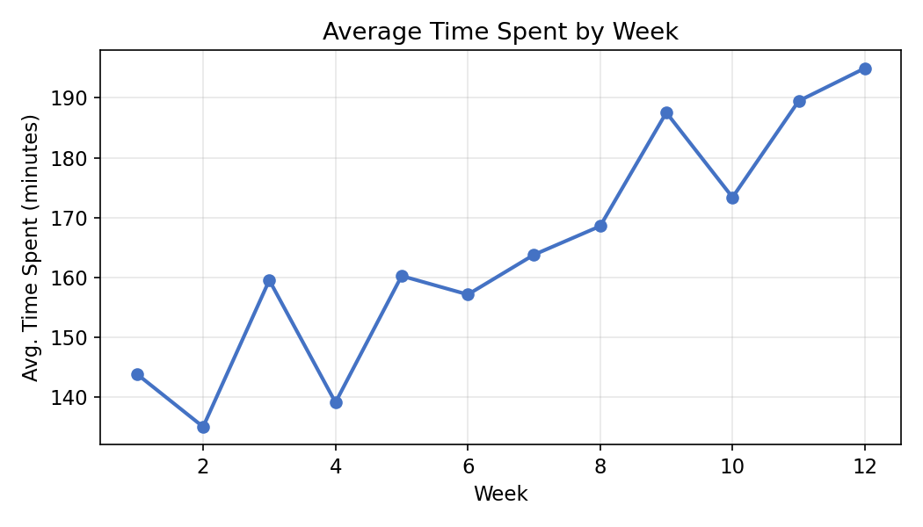

- Which courses have the highest average engagement scores?
Visualization: Bar chart comparing average Engagement Score by Course Name.

Screenshot of visualisation:

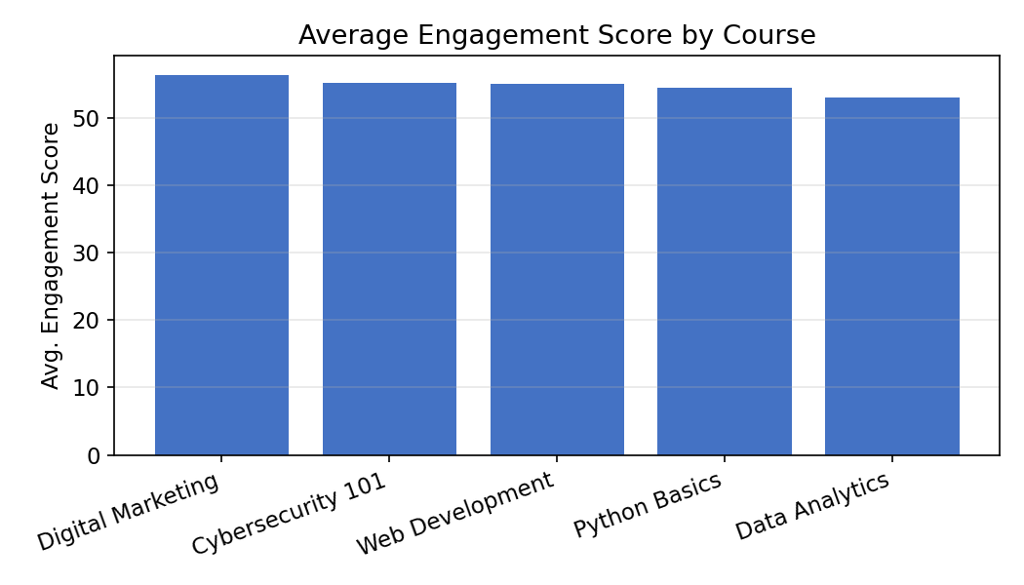

- How does attendance percentage vary across student groups?
Visualization: Bar chart of average Attendance Percentage by Student Group.

Screenshot of visualisation:

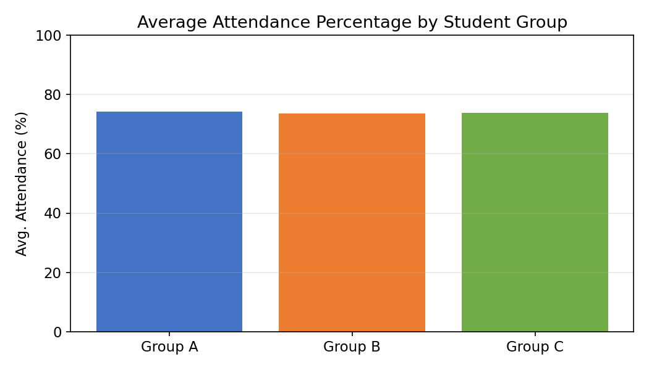

- What is the relationship between time spent and final performance score?
Visualization: Scatter plot of Time Spent vs. Final Performance Score, with a trend line.

Screenshot of visualisation:

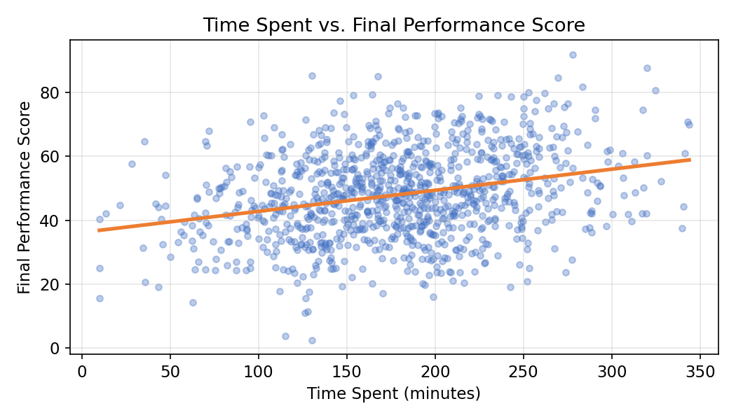

- What percentage of students fall into each engagement level (Low / Medium / High)?

Visualization: Donut chart showing the proportion of students in each Engagement Level category.

Screenshot of visualisation:

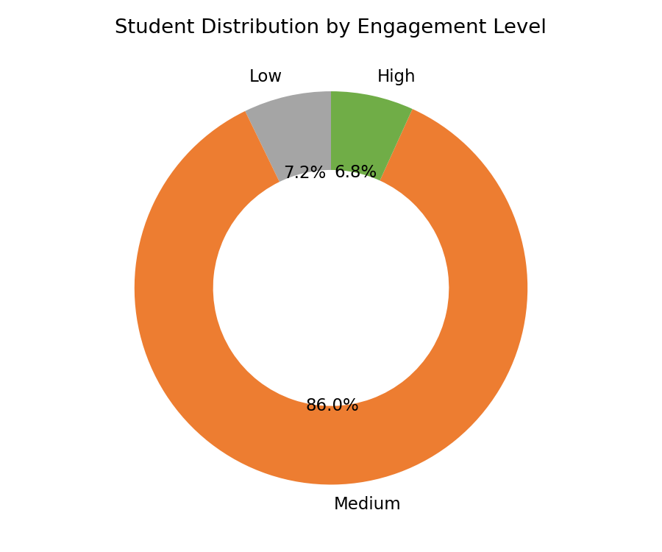

- How do quiz attempts correlate with final performance score?
Visualization: Scatter plot of Quiz Attempts vs. Final Performance Score, with a trend line.

Screenshot of visualisation:

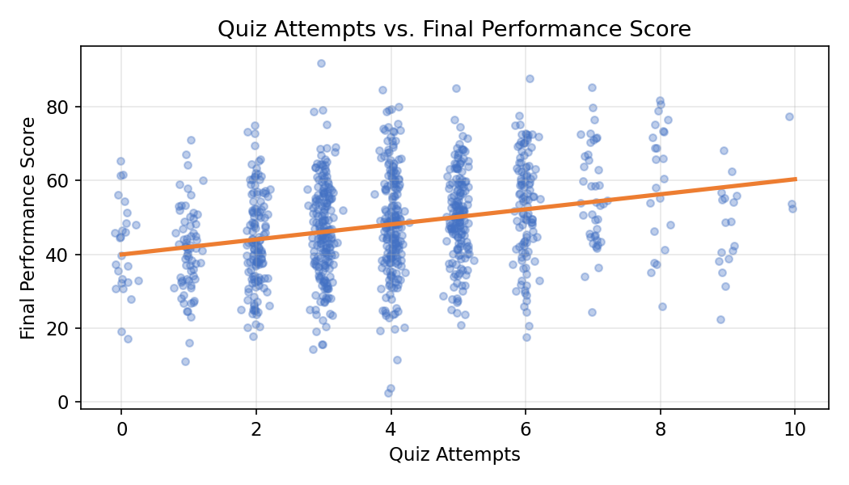

- What is the average performance score by course?
Visualization: Bar chart comparing average Final Performance Score across Course Name.

Screenshot of visualisation:

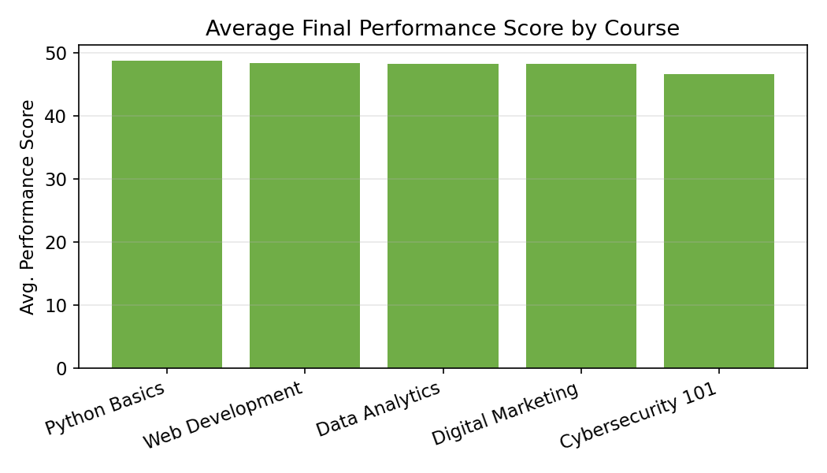

- What proportion of students are at risk (low engagement combined with low performance)?

Visualization: KPI gauge showing the percentage of at-risk students, with red/amber/green zones.

Screenshot of visualisation:

